868/915MHz Band Bi-directional signal amplification module
Technical Specification
Model：AB-IOT-433
Introduction
The AB-IOT-433Series Bi-directional signal amplification module is suitable for micro-power wireless products in the frequency range of 420MHz-480MHz. The module is only the size of a single coin, with simple peripheral circuits and stable operation, and can be applied in scenarios such as 433.92MHz/470MHz wireless data acquisition systems.

Main characteristics
- Built-in TX/RX automatic switching circuit, TX/RX status can be switched independently without external control signal.
- It works in RX status by default, and enhances the receiving signal. When the transmitting signal of the superior device is detected, the module instantly switches to the TX status.
- The TX gain is adjustable, which is convenient to be compatible with wireless devices with different transmission powers.
- Compatible with various modulation methods such as LORA and FSK/ASK/OOK/MSK/GFSK.

Specifications
Working frequency： | 420MHz – 480MHz
RX gain： | 11dB±2dB
NF： | ≤2.0dB
TX gain： | 5dB – 11dB (±2dB)Adjustable
TX/RX switching threshold： | -2dBm
TX input power range： | 1dBm - 20dBm
Maximum transmit power： | 31.5dBm (1.4w) at 3.7V supply voltage  33.5dBm (2.3w) at 5.0V supply voltage  34.5dBm (2.8w) at 6.0V supply voltage
Status indication ： | RX status： Green light is on, Blue light is off
Status indication ： | RX status： Blue light is on, Green light is off
Operating Voltage ： | 供电电压介于3.6V-6.0V之间均可。  最大发射功率随供电电压升高而增加。
Working current ： | RX status ：10mA（±3mA）
Working current ： | TX status ：≤720mA
Overall dimension : | 38.2mm*26.2mm*4.5mm(L*W*H)

Tips: The output power of the upper-level device must be at least 3dB higher than the switching threshold, which means that the output power of the upper-level device cannot be lower than 1dBm, otherwise it may cause unstable operation.

Chang the TX Gain
When the potentiometer is turned counterclockwise to the limit, the gain is 5dB；
When the potentiometer is turned clockwise to the limit, the gain is 11dB.

Overall dimension and Pin description
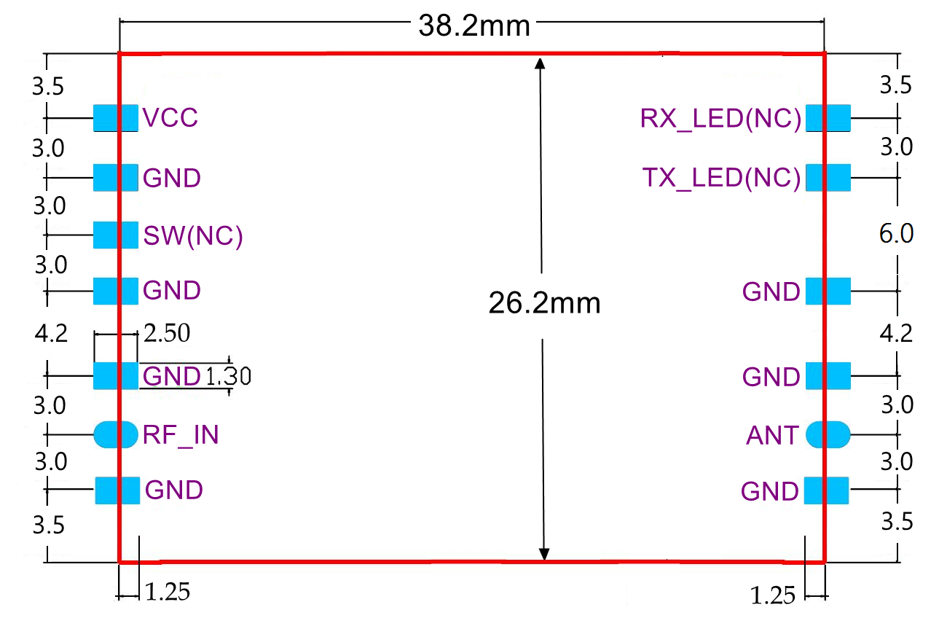
1．The RF_IN pin is connected to the upper-level device RF signal output port.
2． The ANT pin is connected to the Antenna.
3． When the module outputs at maximum power, the current can reach 720mA，It is recommended to connect a large-capacity capacitor in parallel with the VCC pin, the capacity is not less than 220uF.
4 . All pins marked with NC are used in specific occasions, please ignore them for general applications.
5 . This module supports the switching state of the transceiver is controlled by the MCU IO port.

Reference design

